 **Assignment Cover Sheet**

|  |  |  |
| --- | --- | --- |
| **Student Information (For group assignment, please state names of all members)** | | **Grade/Marks** |
| **Name** | **ID** |  |
| Alden Rai Santosa | E1800158 |  |
| I Putu Gede Arya Ramadika Utama | E1800177 |  |
|  |  |  |
|  |  |  |
|  |  |  |
|  |  |  |
|  |  |  |

|  |  |  |
| --- | --- | --- |
| **Module/Subject Information** | | **Office Acknowledgement** |
| **Module/Subject Code** |  |  |
| **Module/Subject Name** |  |  |
| **Lecturer/Tutor/Facilitator** |  |  |
| **Due Date** |  |  |
| **Assignment Title/Topic** |  |  |
| **Intake (where applicable)** |  |  |
| **Word Count** |  | **Date/Time** |

**Declaration**

I/We have read and understood the Programme Handbook that explains on **plagiarism**, and I/we testify that, unless otherwise acknowledged, the work submitted herein is entirely my/our own.

I/We declare that no part of this assignment has been written for me/us by any other person(s) except where such collaboration has been authorized by the lecturer concerned.

I/We authorize the University to test any work submitted by me/us, using text comparison software, for instances of plagiarism. I/We understand this will involve the University or its contractors copying my/our work and storing it on a database to be used in future to test work submitted by others.

Note: 1) The attachment of this statement on any electronically submitted assignments will be deemed to have the same authority as a signed statement.

2) The Group Leader signs the declaration on behalf of all members.

|  |  |
| --- | --- |
| Signature: I Putu Gede Arya Ramadika Utama | Date: 09/04/2021 |
| E-mail:aryaramadika@icloud.com |  |

|  |
| --- |
| **Feedback/Comments\*** |
| **Main Strengths** |
|  |
|  |
|  |
|  |
|  |
|  |
|  |
| **Main Weaknesses** |
|  |
|  |
|  |
|  |
|  |
|  |
|  |
| **Suggestions for improvement** |
|  |
|  |
|  |
|  |
|  |
|  |
|  |

|  |  |
| --- | --- |
|  | **Student acknowledge feedback/comments** |
|  |
| Grader’s signature | Student’s signature: Alden Rai Santosa |
| Date: | Date:09/04/2021 |

Note:

A soft and hard copy of the assignment shall be submitted.

The signed copy of the assignment cover sheet shall be retained by the marker.

If the Turnitin report is required, students have to submit it with the assignment. However, departments may allow students up to **THREE** (3) working days after submission of the assignment to submit the Turnitin report. The assignment shall only be marked upon the submission of the Turnitin report.

*Use additional sheets if required.

Table of Contents

**Design Specification** 1

**Updated Wireframe Design** 1

**Generate Test Report Wireframe** 1

**Manage Kit Stock** 2

**Update Patient Data** 2

**Problem Faced in Interation 1** 3

**Iteration 2** 4

Prepared by : I Putu Gede Arya Ramadika Utama 4

**Use Case** 4

**Test Objectives** 4

**Test Plan** 4

**Test Result** 5

**Unit testing** 5

**Intergration Testing** 8

**System Testing** 9

**Update Prototype Iteration 2** 10

**Test Analysis Report** 11

**Updated Gantt Chart** 11

Prepared by : Alden Rai Santosa 12

**Use Case** 12

**Test Objectives** 12

**Test Plan** 12

**Test Result** 13

**Unit testing** 13

**Intergration Testing** 15

**System Testing** 16

**Update Prototype Iteration 2** 17

**Test Analysis Report** 18

**Updated Gantt Chart** 19

**Conclusion/Review** 20

Prepared by : I Putu Gede Arya Ramadika Utama 20

Prepared by : Alden Rai Santosa 21

# **Design Specification**

In the design specification for task 3, we have an additional update for the V-Sense Covid Testing Information System (CTIS) project on the wireframe design , where we add a new page to our project which is a page to manage kits stock by the test manager.

For Entity Relationship Diagrams (ERD), System Sequence Diagrams (SSD,) Class diagrams, use cases, and sitemaps, which remain the same as what we have included in assignment 1 and assignment 2 documents. Where in the previous document we have met the requirements predetermined.

# **Updated Wireframe Design**

## **Generate Test Report Wireframe**

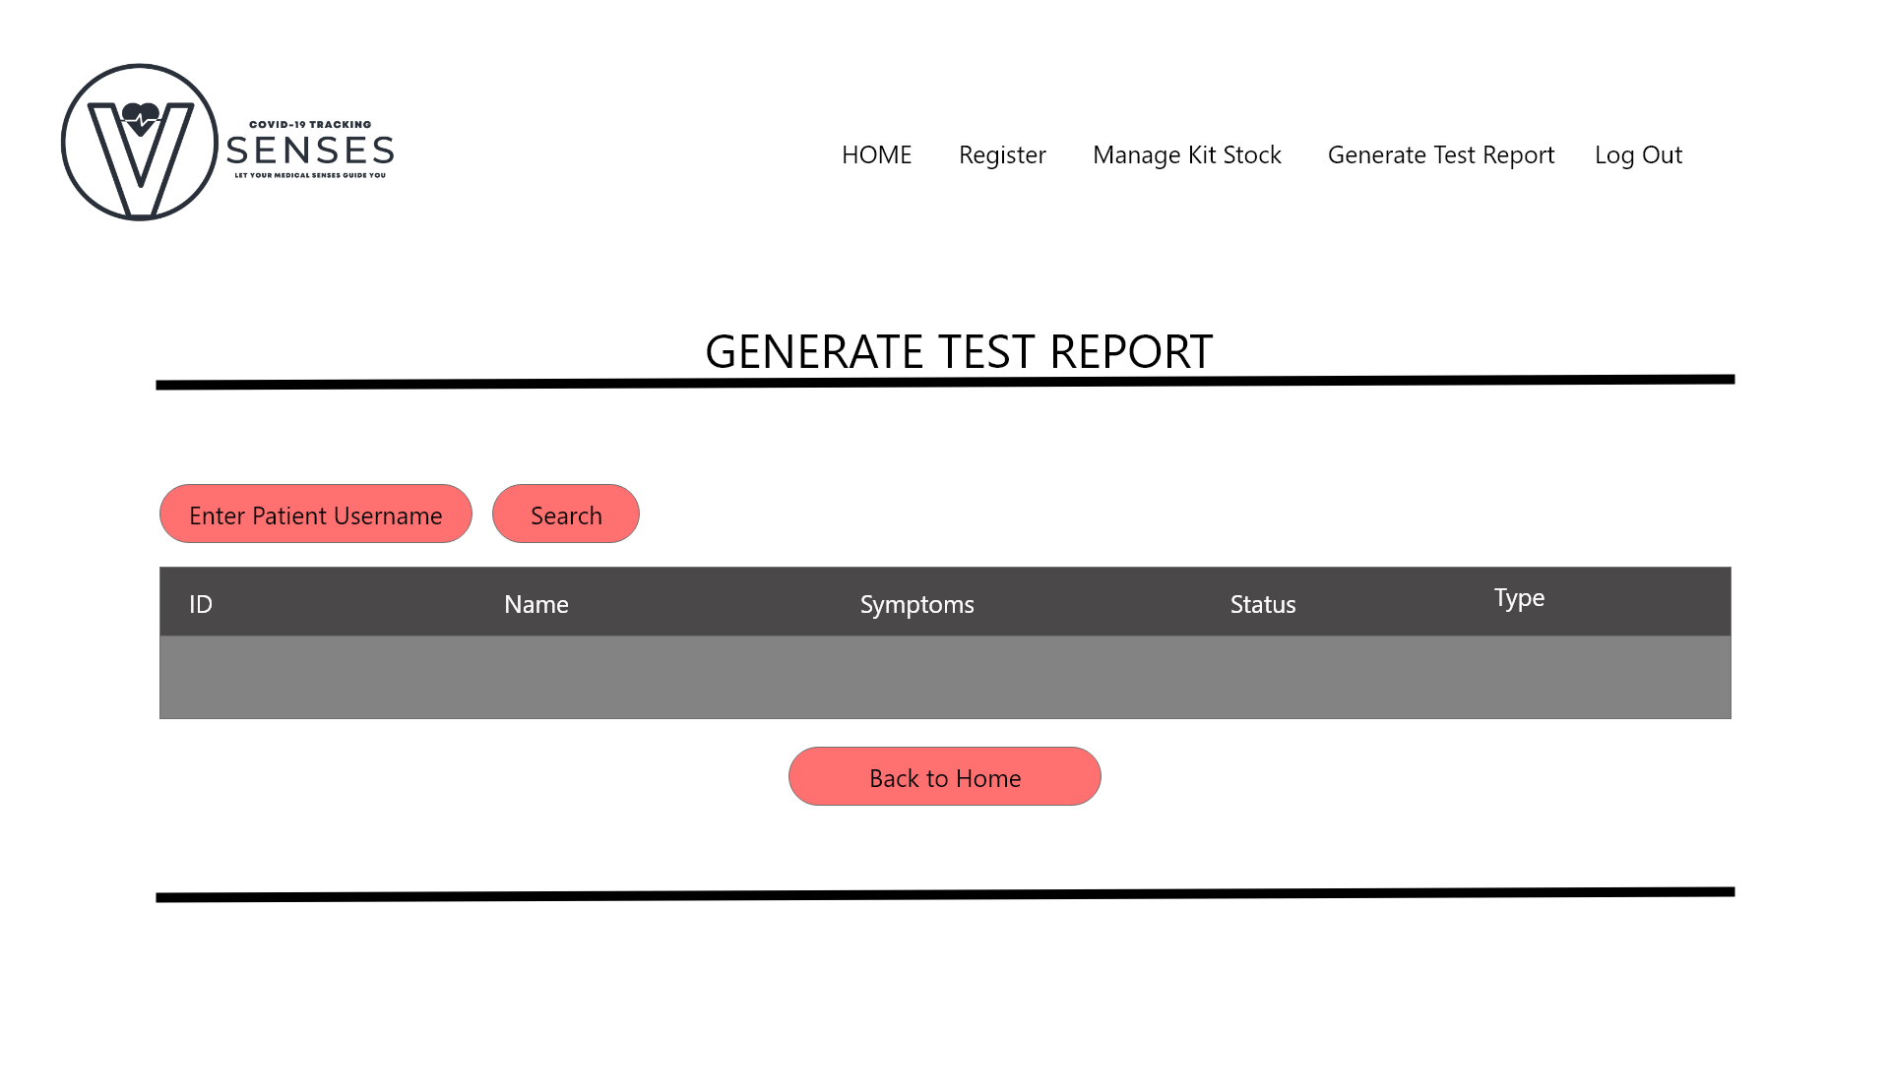

## **Manage Kit Stock**

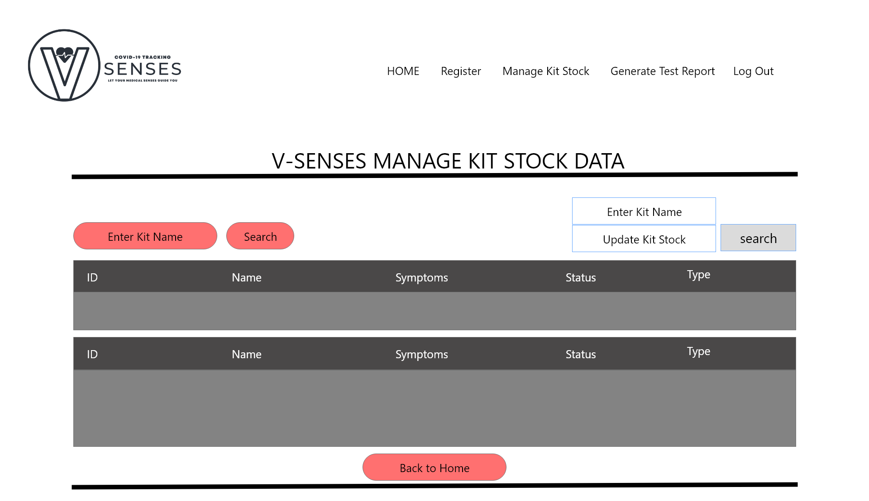

## **Update Patient Data**

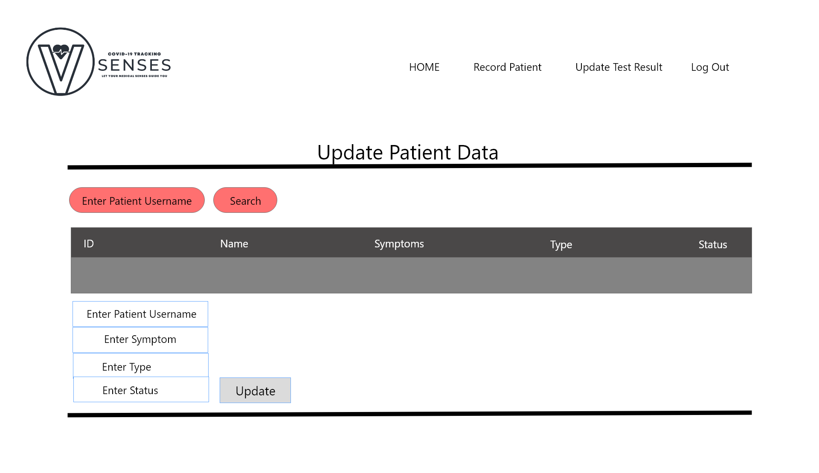

# **Problem Faced in Interation 1**

|  |  |
| --- | --- |
| Problem | Solution |
| Lack of knowlegde of the requirements that is needed within this project | Hold more regular meetings to discuss between project manager with team members and conduct research more often to reduce the risk of a lack of understanding of the project being developed |
| System imperfection | To overcome this problem, all team members must be able to carry out time management well, so that the work and completion of tasks can be carried out optimally. |
| Different opinions between team members which cause difficulties in making decision. | Mitigated which having a solution in preventing this risk by communicating and having more intense discussions within team members. |

# **Iteration 2**

# Prepared by : I Putu Gede Arya Ramadika Utama

## **Use Case**

|  |  |  |
| --- | --- | --- |
| Use Case | Developed By | Iteration |
| Generate Test Report | Rama | Iteration 2 |
| Generate Patient Personal Data | Rama | Iteration 2 |

## **Test Objectives**

Testing is one of the stages of software development that must be carried out to ensure that the program or system being developed is following specified needs. The testing stage aims to observe, record the results or outputs and make an evaluation of several aspects of the system or program being developed that have or have not reached the specified requirements.

Testing in the development of the V-senses Covid Tracking Information system has the aim of ensuring that all processes that occur in the system run well and are following what is desired. First, ensure that the registration process is successful and that the data entered is stored in the database. Second, ensure that all validations in the login run well and ensure that the password is properly encrypted to maintain the security of users' privacy.

## **Test Plan**

|  |  |  |  |
| --- | --- | --- | --- |
| Type of Testing | Strategy/Approach | Tools (if any) | Schedule |
| Unit Testing   * Generate Test Report * Generate Patient Personal Data | White box – code review (code inspections) |  | Gantt chart  23/03/2021 – 30/04/2021 |
| Integration Testing | Black Box  Big - Bang |  |  |
| Functional Testing | Black Box |  |  |
| Non-Functional Testing | Black Box |  |  |

## **Test Result**

### **Unit testing**

|  |  |  |  |  |
| --- | --- | --- | --- | --- |
| Test ID | 1 | | | |
| Use Case | Generate Test Report | | | |
| Test Description | Generate Patient test report based on their username | | | |
| Source Code | <?php  $connection = mysqli_connect("localhost", "root", "", "fullstack_assignment02");  if(!$connection)  {  die("connection failed: ". mysqli_connect_error());  }  if(isset($_POST['search']))  {  $Pusername = $_POST['patientUsername'];  $query = "SELECT * FROM patientrecord WHERE patientUsername = '$Pusername' "; $query_run = mysqli_query($connection, $query);  if (!$query_run) {  printf("Error: %s\n", mysqli_error($connection));  exit();  }  while($row = mysqli_fetch_array($query_run))  {  ?>    <tr>    <td><?php echo $row['ID']; ?></td>  <td><?php echo $row['patientName']; ?></td>  <td><?php echo $row['patientUsername']; ?></td>  <td><?php echo $row['symptoms']; ?></td>  <td><?php echo $row['types']; ?></td>  <td><?php echo $row['statusPatient']; ?></td>  </tr>    <?php  }    }  ?> | | | |
|  | Test Data | Expected Output | Actual Output | Remark(s) |
| Test Case 1: | Enter Patient Username: “jackie123” | The system will search the patient username inside “patientrecord” database and display the test report. | The system will search the patient username inside “patientrecord” database and display the test report. | Pass |

|  |  |  |  |  |
| --- | --- | --- | --- | --- |
| Test ID | 2 | | | |
| Use Case | Generate Patient Personal Data | | | |
| Test Description | Generate Patient personal test report based on their username | | | |
| Source Code | <?php  $connection = mysqli_connect("localhost", "root", "", "fullstack_assignment02");  if(!$connection)  {  die("connection failed: ". mysqli_connect_error());  }  if(isset($_POST['search']))  {  $Pusername = $_POST['patientUsername'];  $query = "SELECT * FROM patientrecord WHERE patientUsername = '$Pusername' ";  $query_run = mysqli_query($connection, $query);  if (!$query_run) {  printf("Error: %s\n", mysqli_error($connection));  exit();  }  while($row = mysqli_fetch_array($query_run))  {  ?>    <tr>  <td><?php echo $row['ID']; ?></td>  <td><?php echo $row['patientName']; ?></td>  <td><?php echo $row['patientUsername']; ?></td>  <td><?php echo $row['symptoms']; ?></td>  <td><?php echo $row['types']; ?></td>  <td><?php echo $row['statusPatient']; ?></td>  </tr>    <?php  }    }  ?> | | | |
|  | Test Data | Expected Output | Actual Output | Remark(s) |
| Test Case 1: | Enter Patient Username: “jackie123” | The system will search the patient username inside “patientrecord” database and display the test report. | The system will search the patient username inside “patientrecord” database and display the test report. | Pass |

### **Intergration Testing**

|  |  |  |  |  |
| --- | --- | --- | --- | --- |
| Test ID | 3 | | | |
| Use Case | Test Centre Manager : Login🡪Home page🡪Generate Test Report | | | |
| Test Description | Generate Patient test report based on their username. | | | |
|  | Test Data | Expected Output | Actual Output | Remark(s) |
| Test Case 1: | Enter Username: Jackie123 | System will display the patient test report with the username”jackie123”. | System will display the patient test report with the username”jackie123”. | Pass |

|  |  |  |  |  |
| --- | --- | --- | --- | --- |
| Test ID | 4 | | | |
| Use Case | Patient : Login🡪Home page🡪Generate Personal Test Report | | | |
| Test Description | Generate Patient test report based on their username. | | | |
|  | Test Data | Expected Output | Actual Output | Remark(s) |
| Test Case 1: | Enter Username: Jackie123 | System will display the patient test report with the username”jackie123”. | System will display the patient test report with the username”jackie123”. | Pass |

### **System Testing**

|  |  |  |  |  |
| --- | --- | --- | --- | --- |
| Test ID | 5 | | | |
| Use Case | Generate Test Report | | | |
| Test Description | Generate patient test report based on their username | | | |
|  | Test Data | Expected Output | Actual Output | Remark(s) |
| Test Case 1: | 1.Patient Username=”abc” | Display the test report of a particular patient based on their username. | Display the test report of a particular patient based on their username. | Pass |

|  |  |  |  |  |
| --- | --- | --- | --- | --- |
| Test ID | 6 | | | |
| Use Case | Generate Patient’s Personal Test Report | | | |
| Test Description | Generate patient’s personal test report by entering their username | | | |
|  | Test Data | Expected Output | Actual Output | Remark(s) |
| Test Case 1: | 1.Patient’s Username=”abc” | Display patient personal test report by entering their username. | Display patient personal test report by entering their username. | Pass |

## **Update Prototype Iteration 2**

Generate Test Report

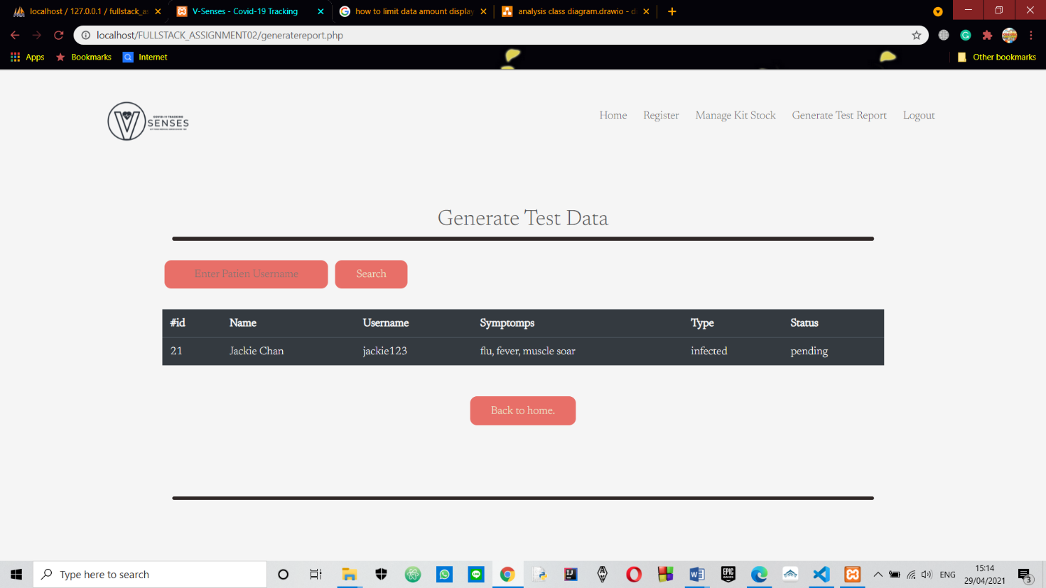

Generate Patient Personal Test Report

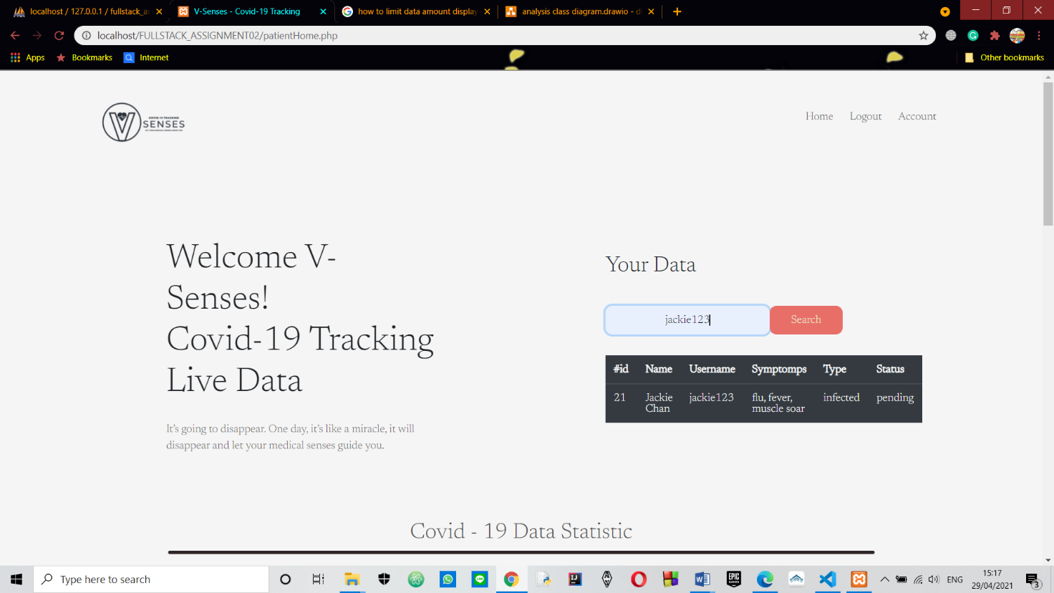

## **Test Analysis Report**

The model that we just tried worked effectively. All the information that has been filled inside the login and registration form are saved inside the database. The error exception was able to identify at whatever point the applicant input the wrong data or doesn’t meet the requirement when filling their information inside the login and registration form.

## **Updated Gantt Chart**

Add “Update Patient Status”.

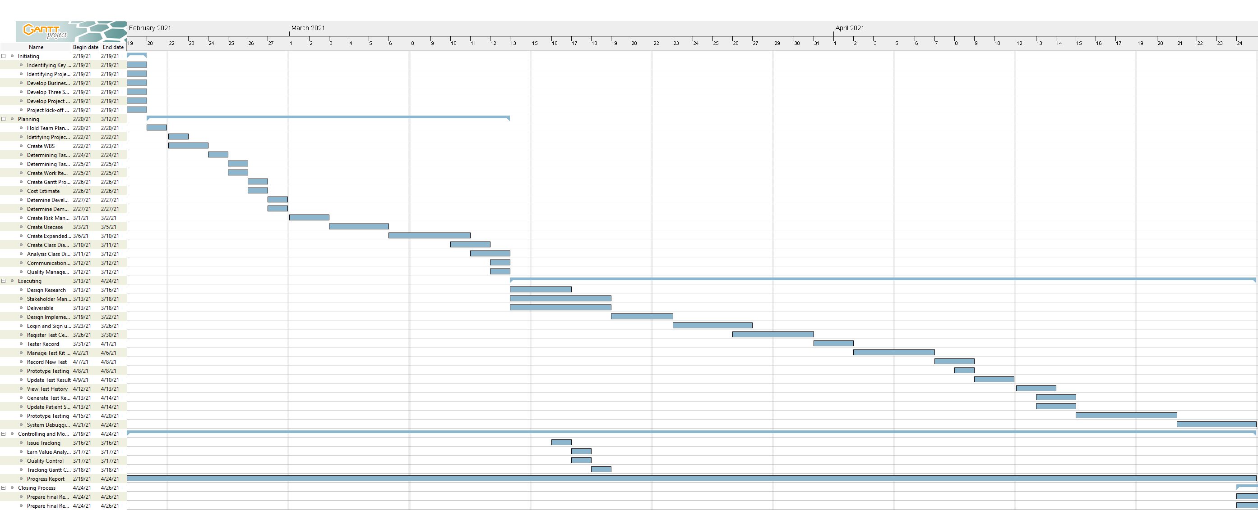

# Prepared by : Alden Rai Santosa

## **Use Case**

|  |  |  |
| --- | --- | --- |
| Use Case | Developed By | Iteration |
| Manage Kit Stock | Alden | Iteration 2 |
| Update Test Report | Alden | Iteration 2 |

## **Test Objectives**

Testing is one of the stages of program advancement that must be carried out to guarantee that the program or system being developed is taking after indicated needs. The testing organizes points to observe, record the results or outputs and make an assessment of a few angles of the system or program being developed that have or have not come to the desired requirements. Testing within the advancement of the V-senses Covid Tracking Information system has the aim of guaranteeing that all processes that happen within the system run well and are following what is desired. First, guarantee that the registration process is successful which the information entered is stored within the database. Second, ensure that all validations within the login run well and guarantee that the password is appropriately encrypted to preserve the security of users' privacy.

## **Test Plan**

|  |  |  |  |
| --- | --- | --- | --- |
| Type of Testing | Strategy/Approach | Tools (if any) | Schedule |
| Unit Testing   * Update Test Result * Manage kit stock | White box – code review (code inspections) |  | Gantt chart  23/03/2021 – 30/04/2021 |
| Integration Testing | Black Box  Big - Bang |  |  |
| Functional Testing | Black Box |  |  |
| Non-Functional Testing | Black Box |  |  |

## **Test Result**

### **Unit testing**

|  |  |  |  |  |
| --- | --- | --- | --- | --- |
| Test ID | 7 | | | |
| Use Case | Manage Kit Stock | | | |
| Test Description | Update amount of kit stock based on the kit name | | | |
| Source Code | <?php  $connection = mysqli_connect("localhost", "root", "", "fullstack_assignment02");  if(!$connection)  {  die("connection failed: ". mysqli_connect_error());  }  if (isset($_POST["stockUpdate"])){  $kitName=$_POST["Kname"];  $updateStock= $_POST["updateStock"];  $query = "UPDATE kitstock SET availableStock='$updateStock' where kitName = '$kitName' ";  $query_run=mysqli_query($connection, $query);  if($query_run)  {  echo '<script type = "text/javascript">alert("Stock has been Updated")</script>';    }  else{  echo '<script type = "text/javascript">alert("Stock has not been updated")</script>';  }  }  ?> | | | |
|  | Test Data | Expected Output | Actual Output | Remark(s) |
| Test Case 1: | Enter Kit Name: “rapid01”  Update Stock Amount: 1000 | The system will search the kit named “rapid01” inside the kit database and update the stock amount of that particular kit to 1000. | The system will search the kit named “rapid01” inside the kit database and update the stock amount of that particular kit to 1000. | Pass |

|  |  |  |  |  |
| --- | --- | --- | --- | --- |
| Test ID | 8 | | | |
| Use Case | Update Patient Status, Symptoms, and Types | | | |
| Test Description | Update Patient Status, Symptoms, and Types based on their username | | | |
| Source Code | <?php  $connection = mysqli_connect("localhost", "root", "", "fullstack_assignment02");  if(!$connection)  {  die("connection failed: ". mysqli_connect_error());  }  if (isset($_POST["patientUpdate"])){  $pUsername= $_POST["patientUsername"];  $symptoms = $_POST["symptoms"];  $type= $_POST["types"];  $status=$_POST["statusPatient"];  $query = "UPDATE patientRecord SET symptoms='$symptoms', types = '$type', statusPatient='$status' where patientUsername = '$pUsername' ";  $query_run=mysqli_query($connection, $query);  if($query_run)  {  echo '<script type = "text/javascript">alert("Data Updated")</script>';    }  else{  echo '<script type = "text/javascript">alert("Data not Updated")</script>';  }  }  ?> | | | |
|  | Test Data | Expected Output | Actual Output | Remark(s) |
| Test Case 1: | 1.Patient’s Username: jackie123  2. Patient’s Symptoms= flu, fever, soar muscle  3. Patient’s Type= infected  4.Patient’s Status= Complete | The system search patient with the username “jackie123” and update the patient’s symptoms, type, status. | The system search patient with the username “jackie123” and update the patient’s symptoms, type, status. | Pass |

### **Intergration Testing**

|  |  |  |  |  |
| --- | --- | --- | --- | --- |
| Test ID | 9 | | | |
| Use Case | Test Centre Manager : Login🡪Home page🡪Manage Kit Stock | | | |
| Test Description | Update Kit Stock amount based on the kit name | | | |
|  | Test Data | Expected Output | Actual Output | Remark(s) |
| Test Case 1: | Enter Kit Name: rapid01  Enter Kit Amount: 1000 | System will update kit stock amount based on the kit name which is rapid01 | System will update kit stock amount based on the kit name which is rapid01 | Pass |

|  |  |  |  |  |
| --- | --- | --- | --- | --- |
| Test ID | 10 | | | |
| Use Case | Update Patient’s Status, Type and Symptoms | | | |
| Test Description | Update patient’s status (pending to complete), type and symptoms based on their username. | | | |
|  | Test Data | Expected Output | Actual Output | Remark(s) |
| Test Case 1: | 1.Patient’s Username=”abc”  2. Patient’s Symptoms=”abc”  3. Patient’s Type=”abc”  4.Patient’s Status=”abc” | Patient status (pending to complete), type and symptoms will be updated based on their username. | Patient status (pending to complete), type and symptoms will be updated based on their username. | Pass |

### **System Testing**

|  |  |  |  |  |
| --- | --- | --- | --- | --- |
| Test ID | 11 | | | |
| Use Case | Manage Kit Stock | | | |
| Test Description | Update stock amount | | | |
|  | Test Data | Expected Output | Actual Output | Remark(s) |
| Test Case 1: | 1.Kit Name=”abc”  2.update amount=”123” | Update the amount of stock in the database based on the kit name. | Update the amount of stock in the database based on the kit name. | Pass |

|  |  |  |  |  |
| --- | --- | --- | --- | --- |
| Test ID | 12 | | | |
| Use Case | Update Patient’s Status, Type and Symptoms | | | |
| Test Description | Update patient’s status (pending to complete), type and symptoms based on their username. | | | |
|  | Test Data | Expected Output | Actual Output | Remark(s) |
| Test Case 1: | 1.Patient’s Username=”abc”  2. Patient’s Symptoms=”abc”  3. Patient’s Type=”abc”  4.Patient’s Status=”abc” | Patient status (pending to complete), type and symptoms will be updated based on their username. | Patient status (pending to complete), type and symptoms will be updated based on their username. | Pass |

## **Update Prototype Iteration 2**

Manage Kit Stock

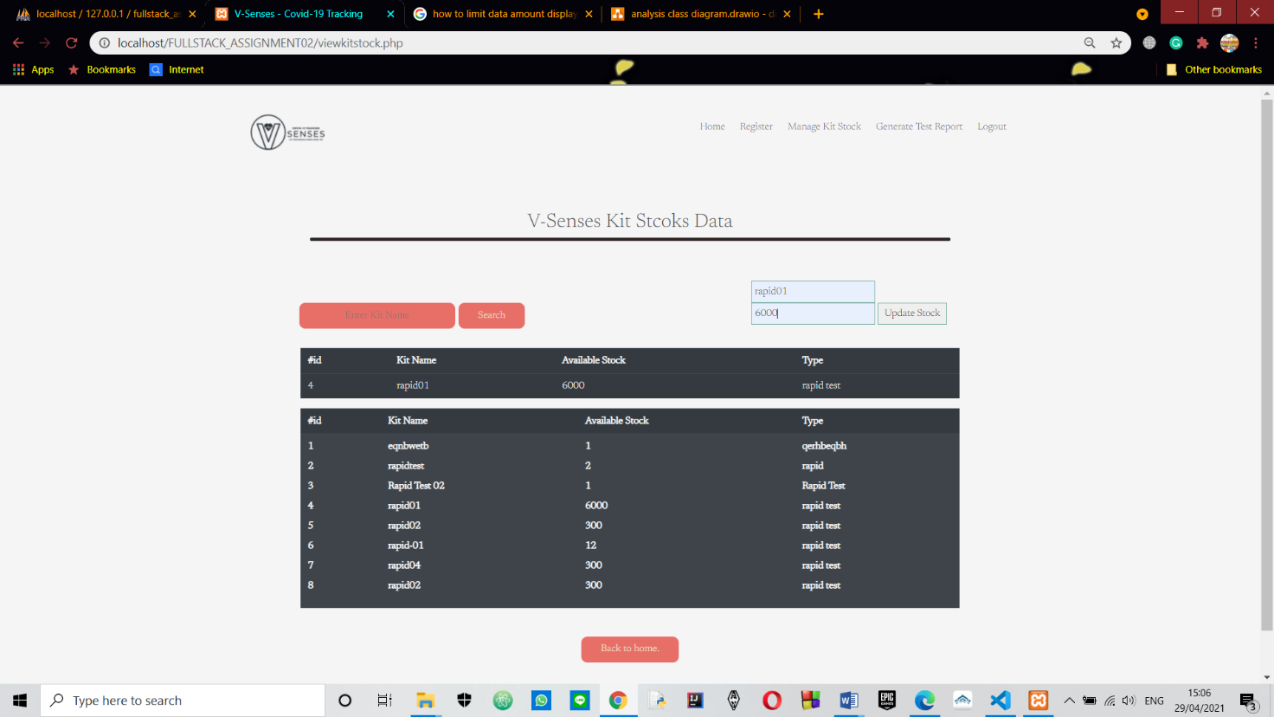

Update patient status, type and symptoms

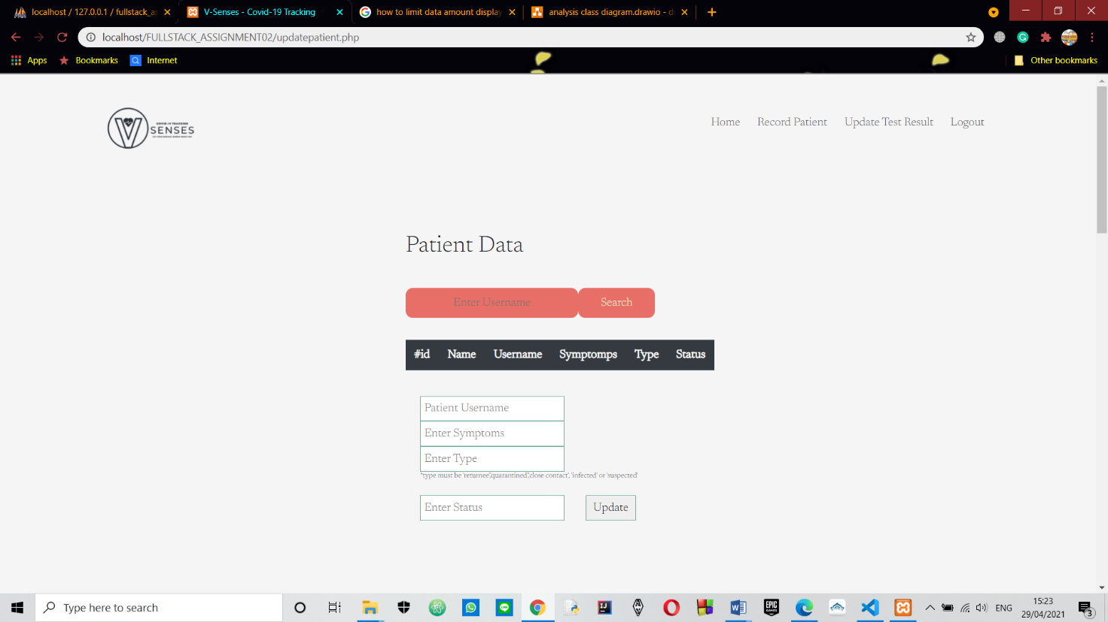

## **Test Analysis Report**

The prototype that we just tested worked successfully. All the data that has been filled inside login and registration form are all save inside the database. The error exception were able to detect whenever the applicant input the wrong information or doesn’t met the requirement when filling their data inside the login and registration form.

## **Updated Gantt Chart**

Add “Update Patient Status”.



# **Conclusion/Review**

## Prepared by : I Putu Gede Arya Ramadika Utama

* Did the group meet the objectives defined in Assignment 1?

All the requirements and objectives that we determined at the beginning of the project, namely in assignment 1, were well done at the end of this assignment 3.

* What went wrong and what went right?
  + What went right ??

In completing the V-Sense project, the work went smoothly in accordance with the milestones we had so that it could be completed on time. There were many obstacles we faced during the work on this project, but with the enthusiasm we had and with our cooperation, we were able to complete this project.

* + What went wrong??

In the process of developing the V-Sense project, we faced many challenges and obstacles during the work process, such as there were some use cases that we thought were easy for us to develop but apparently we couldn't do that, so we had to start studying them again from the beginning. This makes our project imperfect, for example we haven't put the date on the test result report and we haven't been able to manage the kit stock properly, where in the kit stock menu we can only add new stock.

* What you would have done differently?

I have made a lot of mistakes on this project, but this has made me learn many things to correct the mistakes I have made and I can avoid them in future projects. In future projects, I will be more serious about working on it, I will divide my time better so that all the criteria that have been determined are achieved well.

## Prepared by : Alden Rai Santosa

* Did the group meet the objectives defined in Assignment 1?

Our group in developing this V-Sense project achieved all of the requirements and objectives that we specified in assignment 1.

* What went wrong and what went right?

what went right? At first, we were thinking whether we can keep up with the schedule or not since there were many problems that we encountered throughout the process but it turns out we were actually able to stay on track based on the milestone that we have predicted. What went wrong? There are many things went wrong especially throughout the software development. For example, there were some use case that we thought it is going to be easy to develop but it turns out we were not able to do it because we were lacking of basic knowledge and we have to learn about it all over again.

* What you would have done differently?

For the next project, I won’t underestimate the things that I have never done before and try to be more initiative in making the project whether if I’m alone or not since I always do the project only if there is my friend which makes me harder to keep up with the schedule and I must torture myself for sleeping late every night.

